Sitecore Calendar. Create events, schedules and appointments.
Benefits
Calendar module helps you to arrange your personal schedule, track events and don’t miss important appointments. With the module you can easily create any event, either single or recurring; make it exposed to public or protected from unwelcome visitors; define personal list of calendars which are of interest to you. The module is completely dynamic. It means that you can even change your schedule directly from the web site, without necessity to have access to Content Editor.
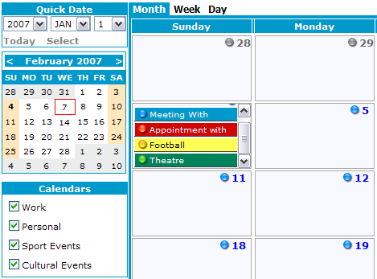
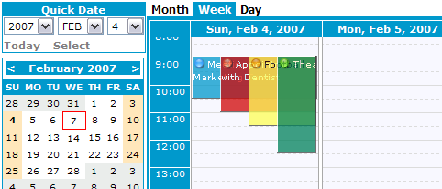

Features
- Online Event Creation: add, delete and modify events from the site’s front-end
- Server Side Event Creation: add, delete and modify events from Sitecore Client Editor
- Dynamic Event Resizing: set event’s End Time with a mouse by simply resizing it on Time Grid
- Drag & Drop: change event’s date by dragging & dropping it with a mouse
- Recurring Events: create a series of events by specifying recurrence rules, i.e. “occur on every first Monday of January of every third year from today till 2017”
- Read-Only Mode: disable editing events from the site’s front-end
- Themes: change look of a calendar at run-time
- Security: create public and private calendars by applying Sitecore Intranet security

Technical
- Events and Calendars are stored in Sitecore CMS as content items
- Use Microsoft Atlas for asynchronous calls from the site’s front-end to server
- Use CSS for Themes
- Fully supported browsers: IE and Mozilla
- .NET Framework

